

**PROJECT TITLE**

**EDUCATIONAL ORGANIZATION USING SERVICE NOW**

**Team id: LTVIP2025TMID30085**

**Team size: 4**

**Team leader: Vattikuti Mounika**

**Team member: P Bala Subrahmanyam**

**Team member: Akana Atma Prasad**

**Team member: Datta Venkata Gandhi**

1. **INTRODUCTION**

**Project Overview**

This project aims to implement and optimize **ServiceNow** to streamline operations within an educational organization. ServiceNow is a leading platform for digital workflows, and it has been selected to improve the efficiency of service management, request handling, and administrative processes. By utilizing ServiceNow’s comprehensive suite of tools, the educational institution will be able to automate critical services and enhance the overall user experience for students, faculty, and staff.

**Purpose**

The purpose of this project is to implement ServiceNow as a service management solution that addresses the following needs within an educational environment:

* Incident Management: Streamlining the process for IT-related issues and service requests, ensuring faster resolution times and better tracking.
* Service Catalouge: Enabling students and faculty to submit requests for various educational resources, such as equipment, access to software, or administrative services.

1. **IDEATION PHASE**

**Problem Statement**

The educational organization currently struggles with managing various service requests, incidents, and administrative tasks across departments. With manual processes and fragmented systems, response times are slow, and there is a lack of real-time visibility into requests and their statuses. Students and staff face frustration due to delays in receiving support, while administrative teams are overwhelmed with a high volume of repetitive tasks. The existing workflows lack automation, leading to inefficiencies and higher chances of errors. Thus, the challenge is to streamline these processes and improve communication, speed, and overall user satisfaction using a centralized service management platform like ServiceNow.

**Empathy Map Canvas**

To truly understand the needs of the end users, we created an **Empathy Map Canvas** to explore their thoughts, feelings, pains, and gains when interacting with the current systems and processes.

* **Students**:
  + **What do they think and feel?**  
    Frustration with slow IT support response times, confusion about where to request resources, and a lack of self-service options for common issues.
  + **What do they see?**  
    Overwhelming amounts of emails, a lack of clear communication, and delayed responses.
  + **What do they hear?**  
    Complaints from peers about slow administrative processes, and unclear instructions on how to resolve issues.
  + **What do they say and do?**  
    Frequently follow up on requests, unsure about the status of their issues, and often have to repeat information to different departments.
  + **Pains**:  
    Slow responses, lack of transparency, and poor user experience.
  + **Gains**:  
    A quicker, streamlined process where they can track requests, receive faster responses, and solve simple issues independently through a self-service portal.
* **Faculty & Administrative Staff**:
  + **What do they think and feel?**  
    Overwhelmed by repetitive administrative tasks, manual ticketing systems, and the lack of integration between departments.
  + **What do they see?**  
    A fragmented system with no central place for all requests, creating confusion and delays.
  + **What do they hear?**  
    Complaints from students and staff about delays in service and support.
  + **What do they say and do?**  
    Manually track requests, spend time coordinating between different departments, and handle multiple systems for different services.
  + **Pains**:  
    Inefficient workflows, confusion about request status, and manual data entry.
  + **Gains**:  
    A unified system where requests can be managed from one place, automated workflows to reduce manual tasks, and greater visibility into the status of issues.

**Brainstorming**

Once the key problems and user insights were identified, a **brainstorming session** was held with various stakeholders to generate ideas on how to address these pain points and deliver a better solution. Some of the ideas that emerged include:

* **Self-Service Portal**:  
  A user-friendly interface where students and faculty can log requests, track incidents, and access common resources (e.g., IT help, equipment requests) without needing to contact support staff.
* **Automated Workflows**:  
  Implementing workflows that automatically route requests to the appropriate departments and assign priorities, reducing the need for manual intervention.
* **Incident Management System**:  
  A streamlined ticketing system that helps track, resolve, and escalate issues in real-time, with automated notifications and updates.
* **Knowledge Base**:  
  A searchable repository of FAQs, troubleshooting guides, and educational resources that students and staff can access to resolve common issues independently.
* **Integration with Existing Systems**:  
  Exploring integrations with student information systems and email platforms to ensure a seamless flow of data and real-time updates.

By combining insights from the empathy mapping and brainstorming sessions, the team was able to define clear, user-centered goals for the project, setting the stage for the next phase of development.

1. **REQUIREMENT ANALYSIS**

The requirement analysis for implementing ServiceNow in an educational organization involves understanding the needs of key stakeholders, including students, faculty, staff, IT teams, and administrators. The primary functional requirements include:

* Incident Management: Automating ticketing, categorizing issues, and routing them to relevant departments.
* Request Management: Enabling users to submit and track service requests via a self-service portal.
* Knowledge Management: Providing a centralized knowledge base for FAQs, troubleshooting, and instructional materials.
* Change Management: Implementing structured approval workflows for IT infrastructure changes.
* Service Catalog: A catalog for users to request IT and non-IT services like course materials or IT resources.
* Reporting & Dashboards: Real-time reporting on KPIs, incident resolution, and request fulfilment rates.
* Automated Notifications: Alerts for ticket status updates and approvals.

Non-functional requirements focus on performance, security, scalability, reliability, and usability, ensuring the system handles peak usage, secures sensitive data, and is easy to navigate. Integration with existing systems like Student Information Systems (SIS), Learning Management Systems (LMS), and email communication platforms is also critical. Additionally, customization for education-specific needs, such as course-related requests and faculty leave approvals, will be necessary.

**4.PROJECT DESIGN**

The design phase focuses on defining the architecture and key components of the ServiceNow implementation. The system will be structured around core modules such as Incident Management, Request Management, Knowledge Management, and Change Management, tailored to the educational environment.

* Architecture: ServiceNow will be hosted on the cloud, ensuring scalability and reliability. Integration with existing systems (e.g., SIS, LMS) will be achieved via APIs to synchronize data and streamline processes.
* Customization: The platform will be customized with specific forms, workflows, and approval processes for education-related requests (e.g., course materials, faculty leave).
* User Interface: A user-friendly self-service portal will be designed for easy navigation by students, faculty, and staff. Automated notifications will keep users informed about ticket statuses and updates.
* Security: Role-based access controls (RBAC) will be implemented to ensure data security, with distinct permissions for different user types (e.g., students, faculty, administrators).

The design will ensure a scalable, secure, and user-centric platform that meets the needs of all stakeholders while integrating seamlessly with existing systems.

**5.PROJECT PLANNING & SCHEDULING**

**Requirement Gathering** --Week 1

***Table & Field Creation*** *--Week 2*

***Business Rule Development****-- Week 3*

***Relationship Setup*** *--Week 4*

***Testing*** *--Week 5*

***Reporting****-- Week 6*

***Documentation & Demo*** *--Week 7*

**6.FUNCTIONAL AND PERFORMANCE TESTING**

Functional Testing will ensure that all ServiceNow modules (Incident Management, Request Management, etc.) perform as expected. This includes validating workflows, data capture, notifications, and integrations with systems like SIS and LMS. Test cases will cover user interactions, role-based access, and request handling.

Performance Testing will evaluate the system's responsiveness under various loads, ensuring it can handle peak usage during high-traffic periods. This includes testing response times for ticket submissions, page loads, and system processing to maintain performance standards under load**.**

**7.RESULTS**

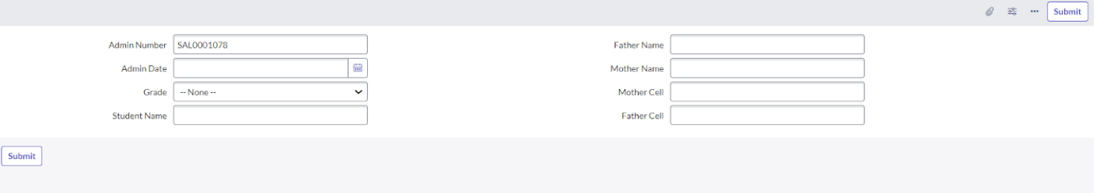

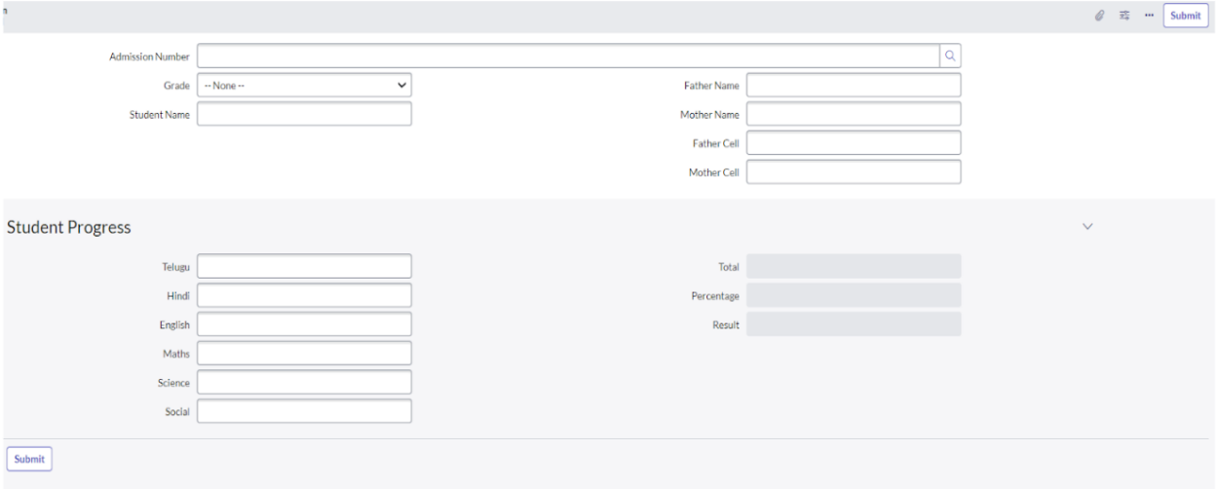

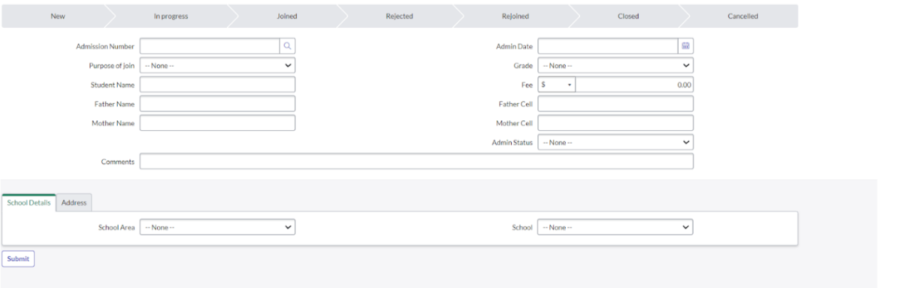

**8.ADVANTAGES & DISADVANTAGES**

**Advantages**

1. Streamlined Processes: Automates routine tasks such as incident management, service requests, and approvals, leading to improved operational efficiency.
2. Improved User Experience: The self-service portal allows students, faculty, and staff to submit and track requests easily, enhancing overall satisfaction.
3. Centralized Knowledge Base: Provides easy access to FAQs and troubleshooting guides, reducing dependency on support teams and enabling quicker resolutions.
4. Integration Capabilities: ServiceNow integrates well with existing systems like SIS and LMS, ensuring smooth data synchronization and workflow automation.
5. Scalability: The cloud-based platform can easily scale to accommodate growing user numbers, services, and functionality.
6. Real-Time Reporting and Analytics: Dashboards and reporting tools offer valuable insights into system performance and service delivery metrics, aiding data-driven decision-making.
7. Security and Compliance: Role-based access control and data encryption help meet regulatory standards (e.g., GDPR, FERPA), ensuring sensitive information is protected.

**Disadvantages**

1. Complex Implementation: Customizing ServiceNow to meet specific educational needs may require significant effort, time, and expertise.
2. Cost: The platform can be expensive to implement and maintain, particularly for smaller institutions with limited budgets.
3. Training Requirements: Both administrators and end-users will need training to effectively use the platform, which could incur additional time and resource costs.
4. Dependency on Internet Connectivity: Being a cloud-based solution, ServiceNow relies on stable internet access, which could be problematic in areas with unreliable connectivity.
5. Overhead in Customization: Over-customization of the platform may result in higher maintenance costs and potential challenges with future upgrades or updates.

**9.CONCLUSION**

The implementation of ServiceNow in an educational organization offers significant advantages in terms of process automation, user experience, and operational efficiency. By streamlining incident management, request handling, and knowledge sharing, ServiceNow can enhance both administrative and academic services, benefiting students, faculty, and staff. However, challenges such as implementation complexity, costs, and the need for training must be carefully managed. Overall, with proper planning and execution, ServiceNow has the potential to transform service delivery, improve stakeholder satisfaction, and support future growth in educational institutions.

THANK YOU !!